U.S. Department of Homeland Security

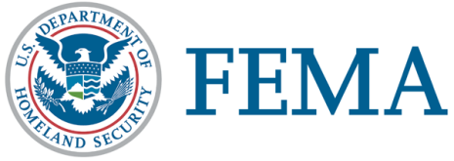
Washington, D.C. 20472

FEMA National US&R Response System

Advisory Organization

Letter of Support
Task Force:
Sponsoring Agency:
Participating Agency
(if applicable):
Date:

The on-going improvement of the National Urban Search & Rescue (US&R) Response System (the System) requires a support system driven by the expertise and commitment of individuals from local, state, and federal levels. The System’s Advisory Organization consists of three elements; the Strategic Group, the Advisory Group, (comprised of Senior Staff, and four Functional Group Leaders) and the Advisory Support Group (comprised of members of the four Functional Groups, Subgroups, Units, and Ad Hoc Groups). These entities work in coordination synergistically to deal with issues facing the System and provide recommendations to move forward.
It is anticipated that members of the Strategic Group will meet quarterly, the Advisory Group will meet semi-annually, and that the Advisory Support Group will meet once a year. These meetings generally last two to three days (plus travel time) and members may also be called upon to participate in periodic conference calls to deal with urgent or time-critical issues. Additionally, members of the Strategic Group and Advisory Group are asked to attend a minimum of one Task Force Representative’s Meeting each year. Individual members may only fill one position at a time within the Advisory Organization, but may serve simultaneously on one Ad Hoc Group or Unit. Costs associated with participation in Advisory Organization activities should be budgeted for, and be paid out of, the current US&R Readiness Cooperative Agreement funds. For some leadership positions within the Advisory Organization, a stipend may be provided through the task forces’ Readiness Cooperative Agreement award to which that member belongs.
Participation is subject to support of the individual member’s Task Force Representative and Sponsoring Agency Chief, and this stipulation applies to Affiliate members as well. If an individual does not work directly for a Sponsoring Agency, support should be obtained from his/her own Participating Agency Chief as well as the Sponsoring Agency Chief. This letter must accompany membership applications and be renewed annually.
This letter authorizes (name of member) to participate in the Advisory Organization, as a member of the (name of group) . This endorsement is valid from this date through the end of the member’s term of appointment, a maximum of three years.
Task Force Representative:
 | Print and Sign | Date
Sponsoring Agency Chief:
 | Print and Sign | Date
Participating Agency Chief:
(If applicable)
 | Print and Sign | Date

